
SEN and Disability
Local Offer: Early Years Settings
Name of Setting: University of Cumbria Pre-School Centre, Lancaster

Setting Name and Address | University of Cumbria Pre-School Centre  University Of Cumbria  Bowerham Road  Lancaster  LA1 3JD |  |  | Telephone  Number | 01524 63124
Setting Name and Address |  |  |  | Website  Address  Local authority  website | U4cpreschoolcentre.co.uk  www.lancashire.gov.uk/SEND
Does the settings specialise in meeting the needs of children with a particular type of SEN? | No | Yes | If yes, please give details:  We cater for every child who meets the age criteria. Staff will work with parents to ensure that individual needs are met.
What age range of pupils does the setting cater for? | 0-5
Name and contact details of your setting SENCO | Mrs Philippa Perks (SENCO)  Mrs Sarah Greene (Deputy SENCO) Rachel Hydes (level3)  TEL: 01524 63124  E-Mail- Philippa@u4cpreschoolcentre.co.uk
We want to ensure that we keep your information up-to-date. To help us to do this, please provide the name and contact details of the person/role responsible for maintaining details of the Local Offer for your setting (this may be the SENCO, manager/supervisor or owner of the setting).

Name of Person/Job Title | Mrs Philippa Perks
Contact telephone number | 01524 63124 | Email | Philippa@u4cpreschoolcentre.co.uk

Promoting Good Practice and Successes

The Local Offer will give your setting the opportunity to showcase any good practice you have around supporting children with Special Educational Needs/Disabilities to achieve their full potential. If you have any examples of good practice or success stories, we would encourage you to include these on your Local Offer web pages. For reasons of confidentiality, please ensure you do not use any personally identifiable information when using case studies to illustrate your setting's experiences of supporting children with SEND.

I confirm that our Local Offer has now been published on the setting website.

Please give the URL for the direct link to your Local Offer
Name | Philippa Perks | Date | 25/08/26

The Setting

The University of Cumbria, graded Good by OFSTED in November 2023 is situated on the University of Cumbria, Lancaster Campus and caters for children aged 0-5 years The setting is open between the hours of 8.00-600 and for 48 weeks of the year.
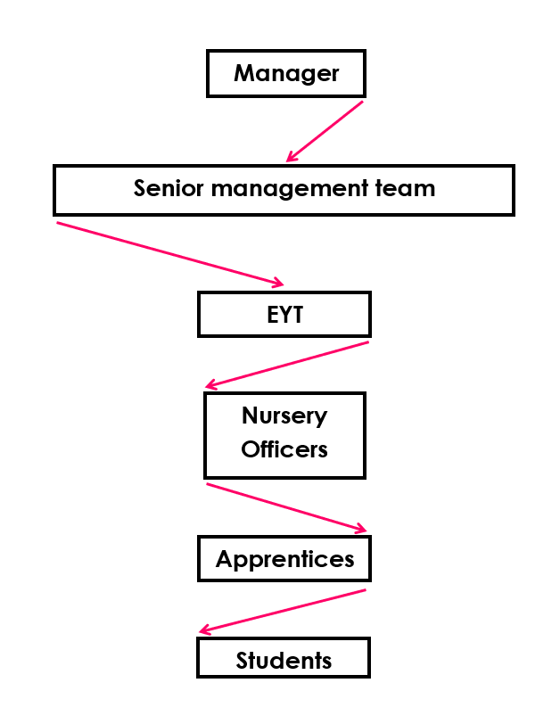

This year a new baby room will become available from September 2025.
The rooms will now be divided in ages as follows

0-15 months
16-24 months
2-3 years
3-5 years

In addition to the Sencos the Centre has a -
PICO (Parent information co-ordinator) Emma Glaister
Enco- (Equality of opportunities Co-ordinator) Lauren Fraser
Panco – (Physical and nutrition co-ordinator) Hayley Mc Farlane

Hayley McFarlane provides staff with up-to-date information and additional training resources through the Institute of Early Education.

ROOM LEADERS

0-2 Hayley Mc Farlane
2-3 Emma Glaister
3-4 Rachel Hydes.

SENIOR LEADERSHIP TEAM

Philippa Perks
Emma Glaister
Rachel Hydes
Hayley Mc Farlane
Lauren Fraser (Early Years Teacher)

Accessibility and Inclusion

The Centres buildings belong to Philippa Perks. The Pre-School Centre site which is a purpose built facility, conforms to all SENDA regulations. The Centre is fully fire compliant and has emergency evacuation plans in place for children who have physical disabilities. The entrance and internal doors are sufficiently wide enough to allow access for wheelchair users.
We are able to communicate with parents/carers through a variety of means: -face to face; home to nursery books; e-mail; EY works and Facebook. The Centre’s ENCO is able to work with families who may have English as an additional language.
We are able to accommodate equipment for use at nursery for children who may have additional needs. We operate a free flow system where children have access to a variety of resources. Where possible resources are stored at the children’s height for accessibility. The rooms have good natural light. Within the Pre-School rooms the windows are at children’s height. Children have independent access to the all-weather outdoor area. The building is all on one level with ramp access to the outdoor classroom. A fully equipped sensory room is located in the 3-4 room for children with additional needs to self- regulate and calm.
Similarly, a forest area has been created as a addition to the outdoor learning environment.

Table and chairs used within the rooms are age appropriate and height adjustable. Furniture can be easily moved and there is adequate space within the environment for wheelchairs, walking frames etc. Practitioners work closely with other professionals to ensure that equipment is used safely, resources are developmentally appropriate and access to equipment is of optimal benefit to the user.

The new Centre has parking provision for 11 cars 2 of which are located near to the entrance door.

Identification and Early Intervention

Where children have known additional needs, the Centre works closely with parents to gather as much information as possible prior to the child starting at the setting. The SENCO will support all key persons to ensure that early identification of needs is made, and the appropriate support can be put in place.

Regular assessment for all children, including baseline profiles and 2-year-old progress checks, takes place. Any areas of concern are quickly identified as pupils tracking is updated termly. As part of this assessment and tracking process, key persons would identify any areas of concern highlighted in this process would be discussed with the child's parents/carer. Parents who believe their child has additional needs would speak with their child’s key worker and SENCO. Together relevant paperwork and information sharing will take place.
Parents are valued as educators too and regular meetings are scheduled for information sharing. If the Centre identifies a specific need we adopt the graduated response as set out by the code of practice and described in our SEN policy. The setting has a comprehensive Special Educational Needs (SEN) policy, and the practitioners have regular training reviews ensuing they have up to date information.

We make use of provision mapping as a tool to highlight how we support all children, including children with additional needs and disabilities. Provision mapping is in place from wave 1 (universal support/provision for all children attending the setting) to wave 3 (targeted support/provision for children with additional educational needs). Wave3 intervention would involve practitioners adopting specific programmes and SENCOs working with other professionals in a multi-agency response. The Centre has developed excellent partnership links with a wide variety of professionals who are able to support us to meet the needs of children with a range of additional needs.

At every targeted intervention parent’s and, where possible, the views of the children are considered, and strong partnership working is advocated. Parents are encouraged to contribute to Targeted Learning Plans, meet with other professionals and become involved in Team around the Family Reviews.

Teaching and Learning Part 1 – Practitioners and Practice

The Centre prides itself on having a fully qualified, long serving staff team. We employ a teacher who also has Early Years Teacher Status. The Manager holds level 7 qualifications in fields relevant to her roles and responsibilities. The Early Years Teacher leads the practice, but all staff members play a pivotal role in developing and delivering the Birth to Five Matters guidance.

Parents and children play an active role in the children’s learning and development. The key to successful planning is the continuous monitoring of the progress of the children. Practitioners through regular observations track the children’s progress and build upon their experiences to ensure active learning. For all children a baseline assessment is made after 3 weeks and then each term parents are provided with progress sheets. Parents are actively encouraged to contribute to their child's development

Learning journeys provide a visual record of how the children have grown, developed and progressed throughout the time at nursery. Keyworkers play an important role in building positive relationships, providing a stimulating environment and developing independent learning.

In addition to the cycle of observation, assessment and planning detailed provision mapping illustrates how we provide experiences, opportunities and support for all children dependent upon their needs and stages of development. Where they are required targeted learning plans, we provide clear achievable targets that are written with external advisors' and parental contributions.

For children who have additional needs, the Centre employs a SENCO. The SENCO works extremely closely with parents, keyworkers and outside agencies to ensure that each and every child reaches their full potential.

Communication links are very effective at the Centre. Parents have access to an up-to-date notice board; e-mail; parent zone on EY works and Facebook to keep up to date with local events and Pre-School Centre news. The Centre has a website:-
www.u4cpreschoolcentre.co.uk

Teaching and Learning Part 2 - Provision & Resources

All children have access to resources within the learning environment. Staff display children’s work, showing that the children are valued, and the work is praised for effort rather than outcome. Staff are encouraged to adopt a growth mindset approach to children’s learning and development.

Resources are appropriate for the age and stage of development of the children, and the furniture and larger pieces of equipment are moveable between areas. If making a purchase of equipment for a child with additional needs, advice will be sought from parents and other professionals and staff welcome training to ensure equipment is being used correctly.

SEN funding is allocated separately from the main resources budget. Details of what is purchased also are filed separately to ensure that the purchases are appropriate and meet individual needs.

The setting has a supernumerary Manager and Welfare Assistant, these additional staff can support practitioners within the classrooms by improving the ratio of staff to pupils and allow for small group activities or one to one support.

Provision mapping at wave 3 ensures targeted support for all children with additional needs. The team work very closely with a range of professionals. Good relationships have been built up with the Inclusion Service, the local Child Development Centre (Longlands), Speech and Language therapy services, Occupational Therapy and Physiotherapists to support all areas of development.

All children are encouraged to take part in every nursery activity: -sports; forest school. Children have constant access to the outdoor environment. Parents are encouraged to support their children on Centre trips to the theatre, local museums and other places of interest. The Centre has developed a small Forest School which is in close proximity to the main site.

Children who have additional needs will have an access plan in place and where appropriate a fire evacuation plan. The Centre uses Pennine Fire Services to maintain fire safety equipment and write the fire risk assessments and access plans.

Reviews

Parents are regularly kept up to date with their children’s progress. An All about Me book is completed on entry. After 3 weeks of attending Pre-School an ‘activities and interest’ sheet is completed. This is photocopied, handed back to the parent/carer and forms the baseline assessment highlighted on the tracking documents. Each term, the tracking books are updated and once again an ‘interest and activities’ sheet is handed out for parents to view and contribute to. The 2-year-old progress check is completed between the ages of 2 year 3 months and 2 years 9 months. This once again this is shared with parents’ permission is sought from parents to share the information with colleagues from Health.

Learning journeys are located in the classroom and are easily accessible for parents to take home and look through. Parents are encouraged to contribute to learning journeys, planning sheets and tracking books.

The Centre has an open-door policy, so parents can discuss the needs of their children with staff members during the day. A parents evening/appointment time is made for children who are leaving to go to school. During this meeting the nursery teacher will share tracking with parents and discuss their final nursery report.

Both the SENCO and keypersons will contribute to any meetings with other professionals and will attend TAF and TLP reviews when staff ratios allow.

Transitions

What the setting provides

Parents are encouraged to visit both the baby unit and pre-school centre before stating at the setting. Settling in visits are planned and agreed by staff and parents.

If children attend more than one setting, then links are made with other providers so a full picture is being built of the child’s experiences and interests. Staff are aware that transitions away from the Centre may also have an impact upon the children’s learning and development and we will work with parents to support the children along the way.

Transitions between rooms aim to ensure that children settle into their new environments quickly and seamlessly. Children spend time in their new rooms and become acquainted with their new keyperson. Staff share information on a needs to know basis and parents are introduced to new staff members.

At the end of the academic year we host a graduation ceremony for all our leavers and each child is presented with a graduation book which depicts their peers and which school they will be attending.
Transitions to school are led by the nursery teacher. Good links have been established between the Centre and the local schools. The setting welcomes visits from school staff and the children are supported in the process of visiting their new schools. For children who have additional needs a formal transition meeting will take place. This is attended by all professionals who have had, or will have, a role in supporting the child.

A fully completed tracking document, comprehensive learning journey and a progress report will be handed over to parents for them to share with school. Parents are encouraged to attend a face to face meeting with the nursery teacher to look through the learning folder and discuss the end of the year report.

Staff Training

Continuous professional development has always been a priority at the setting. The setting has a nominated training officer and future training needs are identified through supervisions. All staff are actively encouraged to undertake regular Continual Professional Development.

The SENCO ensures that training is attended regularly to keep up to date with changes to the legislation etc. All staff members hold a level 2 qualification or above. Two members of staff hold level 7 qualifications another is at level 6. All Mangers have level 3 qualifications or above.

The Centre closes for 1.5 days per year for whole staff training. Recently, the whole staff team undertook Makaton training. Training priorities are driven by the Centre’s Development Plan, and we make use of our very experienced staff team to offer in-service training or we bring in other professionals to provide further insight into specific areas of practice. All staff have an awareness of SEND regulations.

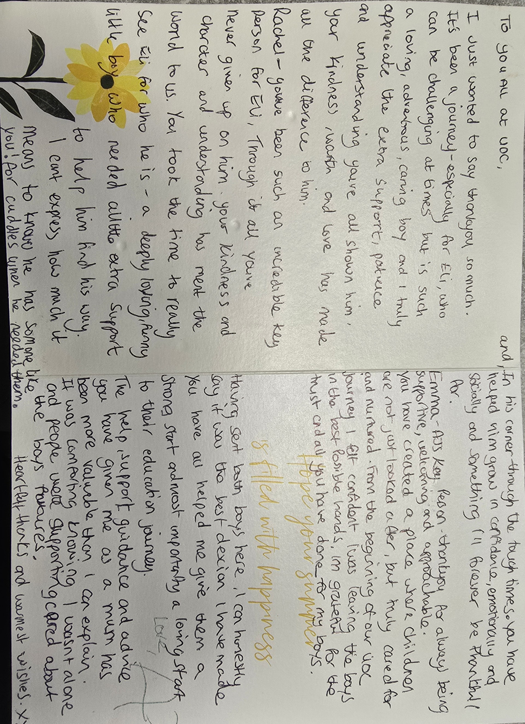
All practitioners regularly up-date the Centre’s mandatory training requirements. This includes: CAF (Common Assessment Framework) level1; First Aid; Health and safety; Food hygiene and Safeguarding level 1. All managers are trained in safeguarding to level 2 or above. Further training opportunities are available from the local authority, in house and private providers.

Further Information

What the setting provides

For further information please contact the Management Team on 01524 63124. The Centre has an Open-Door policy and staff will try to meet with parents as and when required. A member of the management team will always be available at the start and the end of each day.

Appointments with keypersons and Sencos can be made for any child at mutually convenient times.

Web address:-u4cpreschoolcentre.co.uk

E-mail:- Philippa@u4cpreschoolcentre.co.uk

Facebook:- UOC Preschool Lancaster

